**Software Requirements and Design Document**

**For**

**Group <1>**

Version 1.0

**Authors**:

Michael Clark

Phillip Sheng

Christian Riley

# Overview (5 points)

*Give a general overview of the system in 1-2 paragraphs (similar to the one in the project proposal).*

# Functional Requirements (10 points)

1. *Users*  *will be able to place a bet on a sporting event – High*
2. *Users*  *will be able to log in using valid credentials – High*
3. *Users*  *will be able to create an account – High*
4. *Users can claim currency for free using a built in reward system - High*
5. *Bets and sporting events will be refreshed every 24 hours after a sporting event has concluded – Medium*
6. *Users*  *can access resources for gambling addiction through the homepage – Low*

# Non-functional Requirements (10 points)

1. *Usernames will not be repeated.*
2. *Email will not be repeated.*
3. *Ability to find lost password securely*
4. *Bets are cashed out less than 24 hours after a match has concluded*

# Use Case Diagram (10 points)

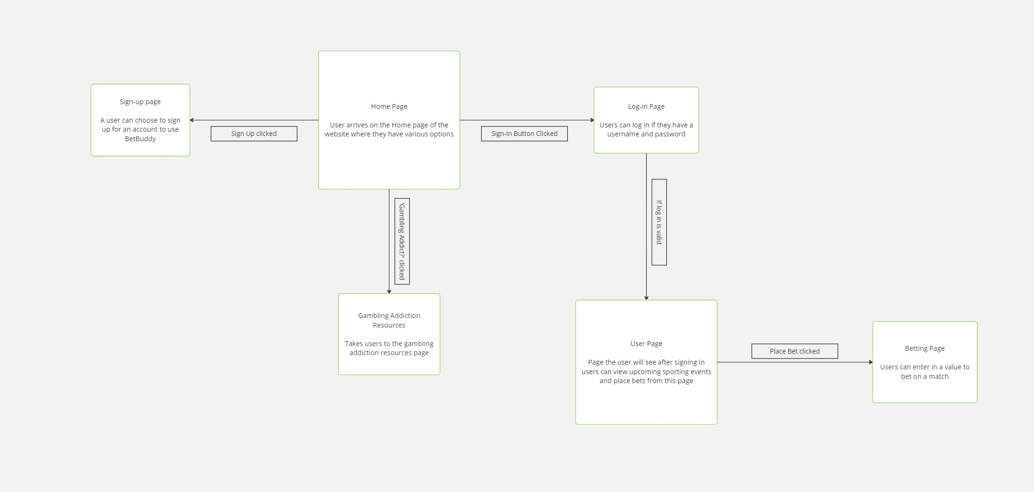

# Class Diagram and/or Sequence Diagrams (15 points)

*It is a Sequence Diagram*

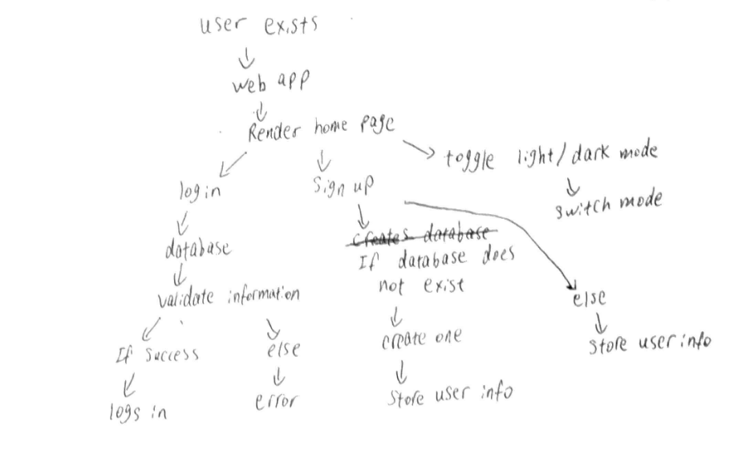

# Operating Environment (5 points)

*Windows 10 and 11, MacOS, Linux. Must have Python installed and a working browser. API must also work*

# Assumptions and Dependencies (5 points)

API is expired or removed by the third party platform. Flask gets taken off from PyPI, Python gets taken off, a browser update that prohibits user from loading localhost, or an operating system update that affects the use of the computer